Module 3: Planning for SLO Assessment Alignment and Rigor

Guiding Question: What Depth of Knowledge (DOK) level was used in the assessments? Use sample SLO Pre- Assessments to complete the table below.
Focus:
- Assessment alignment to TEK
- Developing Depth of Knowledge (DOK) & Rigor
Artifact #1: DOK Breakdown of SLO Assessments

 | DOK 1 | DOK 2 | DOK 3 | DOK 4
Pre-Assessment
Post-Assessment
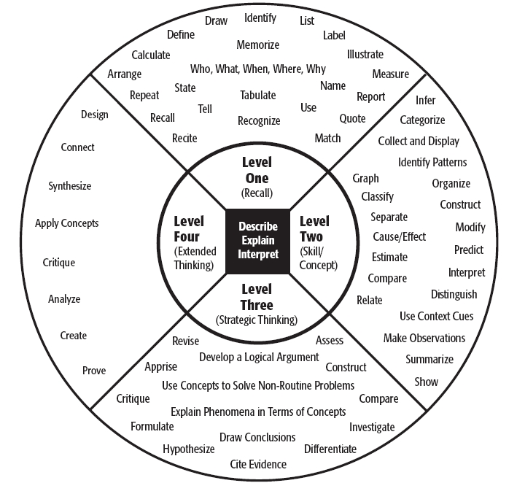

Artifact #2: Assessment DOK and Rigor Outline (DOK & Verb)
Use DOK wheel to create your Assessment DOK & Rigor Outline below

Outline for 2020-2021 Pre- and Post- Instruction Assessments
 | DOK 1 | DOK 2 | DOK 3 | DOK 4
Pre-Assessment
Post-Assessment

Assessment DOK & Rigor Outline
Question # | TEK | TEK Verb Specificity | Level of DOK
S1 | 6.4G generate equivalent values based on proportions | Generate | 2 - predict
1
2
3
4
5
6
7
8
9
10
NOTE: Assessments can be more than 10 questions long. Please review your assessment plan with your administrator.

Extension: If you have completed your Assessment DOK & Rigor Expectation Plan you can begin creating your Pre- and Post- Assessments.
Extension Artifact#3: List of assessment resources used to create assessments

